**TRAFFIC CONTROL FOR THE BLIND**

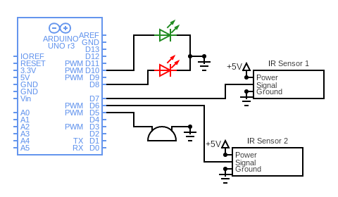

**Working of components**

**Arduino UNO Board:**

The user can get started by connecting the Uno to a computer with the USB cable or by powering it with an AC / DC adapter or battery. The Uno can be programmed with Arduino Software (Integrated Development Environment). Arduino Uno features 14 digital input / output pins (six of which can be used as PWM outputs), six analog inputs, and a 16MHz quartz crystal. Uno also includes a USB connection, a power jack, an In- Circuit Serial Programming (ICSP) header, and a reset button. This Arduino MCU board contains everything the user needs to support the MCU.

**IR Sensor:**

Here we are using two IR sensors. The first IR sensor is connected to the D7 pin and the second one is connected to the D6 pin of Arduino. An IR sensor consists of an IR LED and an IR Photodiode, together they are called as Photocoupler or Optocoupler. Infrared Transmitter is a light emitting diode (LED) which emits infrared radiations called as IR LED’s. Even though an IR LED looks like a normal LED, the radiation emitted by it is invisible to the human eye. Infrared receivers or infrared sensors detect the radiation from an IR transmitter. IR receivers come in the form of photodiodes and phototransistors. Infrared Photodiodes are different from normal photo diodes as they detect only infrared radiation.

Different types of IR receivers exist based on the wavelength, voltage, package, etc. When used in an infrared transmitter – receiver combination, the wavelength of the receiver should match with that of the transmitter. The emitter is an IR LED and the detector is an IR photodiode. The IR photodiode is sensitive to the IR light emitted by an IR LED. The photo-diode’s resistance and output voltage change in proportion to the IR light received. This is the underlying working principle of the IR sensor.

**LEDs:**

We are using two LEDs in this project. Red and green LEDs. The red LED is connected to the D8 pin and the green is connected to the D10 pin of Arduino. The light-emitting diode simply, we know as a diode. When the diode is forward biased, then the electrons & holes are moving fast across the junction and they are combined constantly, removing one another out. Soon after the electrons are moving from the n-type to the p-type silicon, it combines with the holes, then it disappears. Hence it makes the complete atom & more stable and it gives the little burst of energy in the form of a tiny packet or photon of light.

**Buzzer:**

The buzzer is connected to the D5 pin of Arduino. It consists of an outside case with two pins to attach it to power and ground. Inside is a piezo element, which consists of a central ceramic disc surrounded by a metal (often bronze) vibration disc. When current is applied to the buzzer it causes the ceramic disk to contract or expand. Changing the This then causes the surrounding disc to vibrate. That’s the sound that you hear. By changing the frequency of the buzzer, the speed of the vibration’s changes, which changes the pitch of the resulting sound.